## **Creating a Poster in Microsoft PowerPoint**

This guide will show you how to use the PowerPoint poster template provided from the BE Communication Lab. You should first decide whether they want a vertical or horizontal poster and download the appropriate file. The default poster size is 48x36 but can be scaled appropriately when printing.

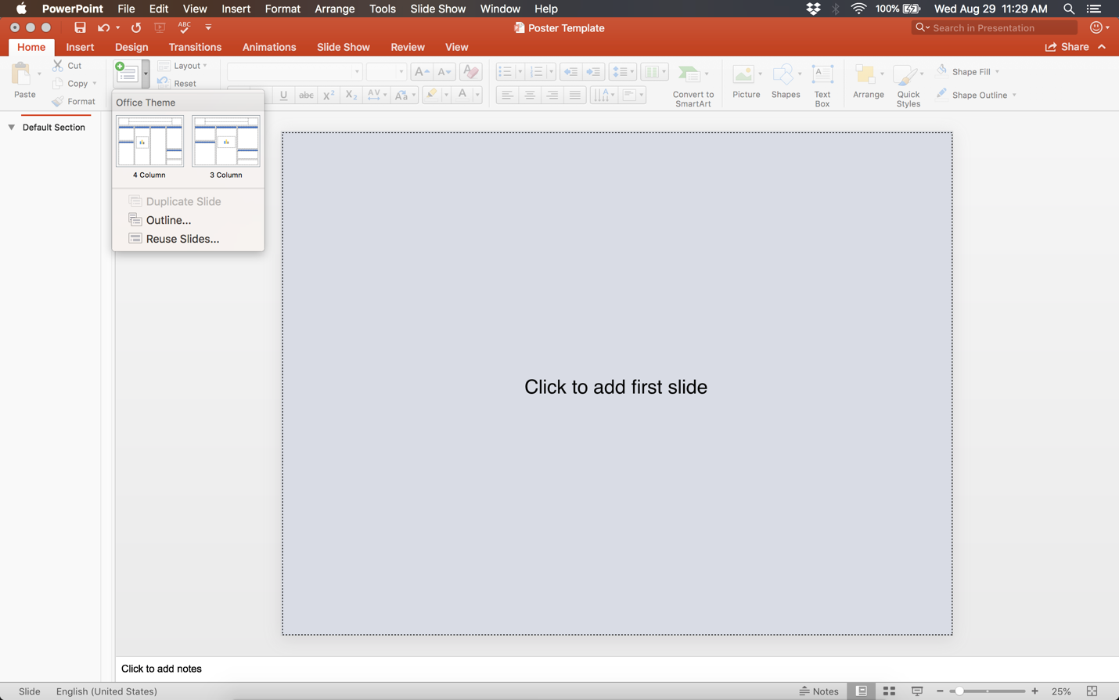Create a new slide to select the number of columns

Either before or after adding your content to the slide, the background, colors, and font can be customized using the “Slide Master”

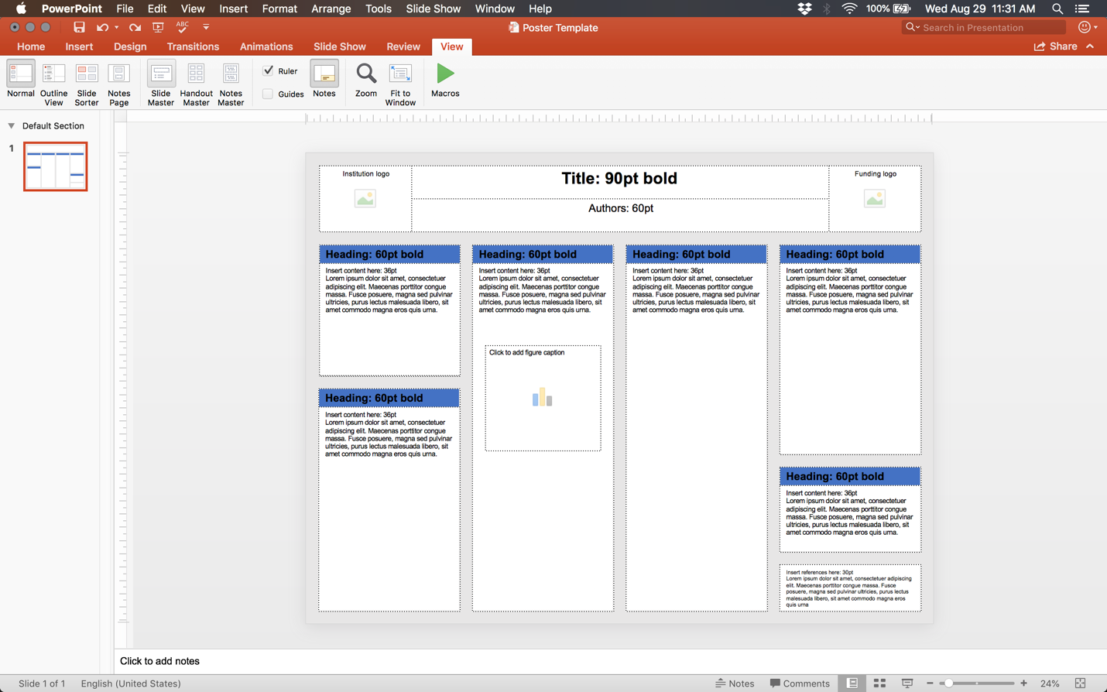

An alternative way to accessing the “Slide Master” is by holding Shift and clicking the Normal view icon at the bottom of the screen

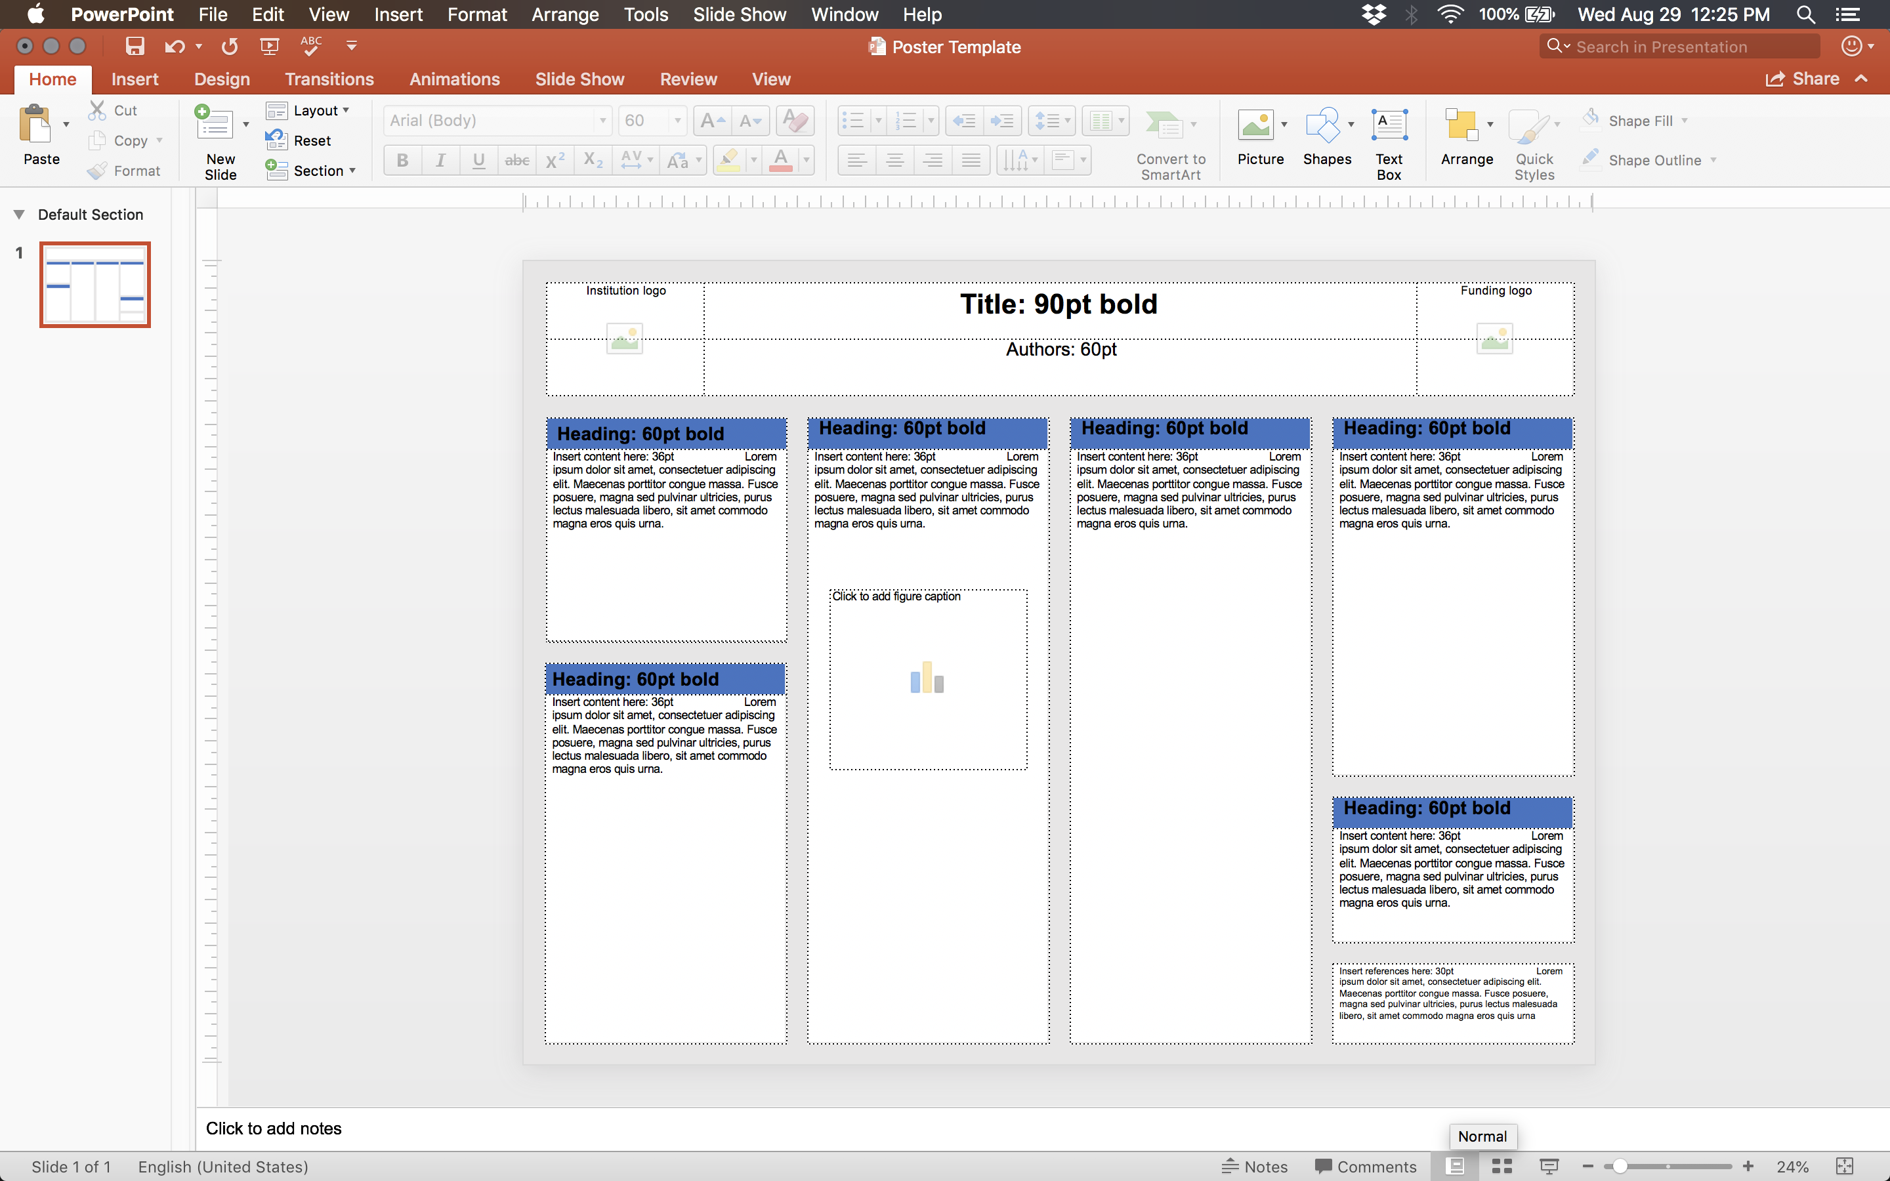

You are editing the Slide Master when the Slide Master header appears in the ribbon

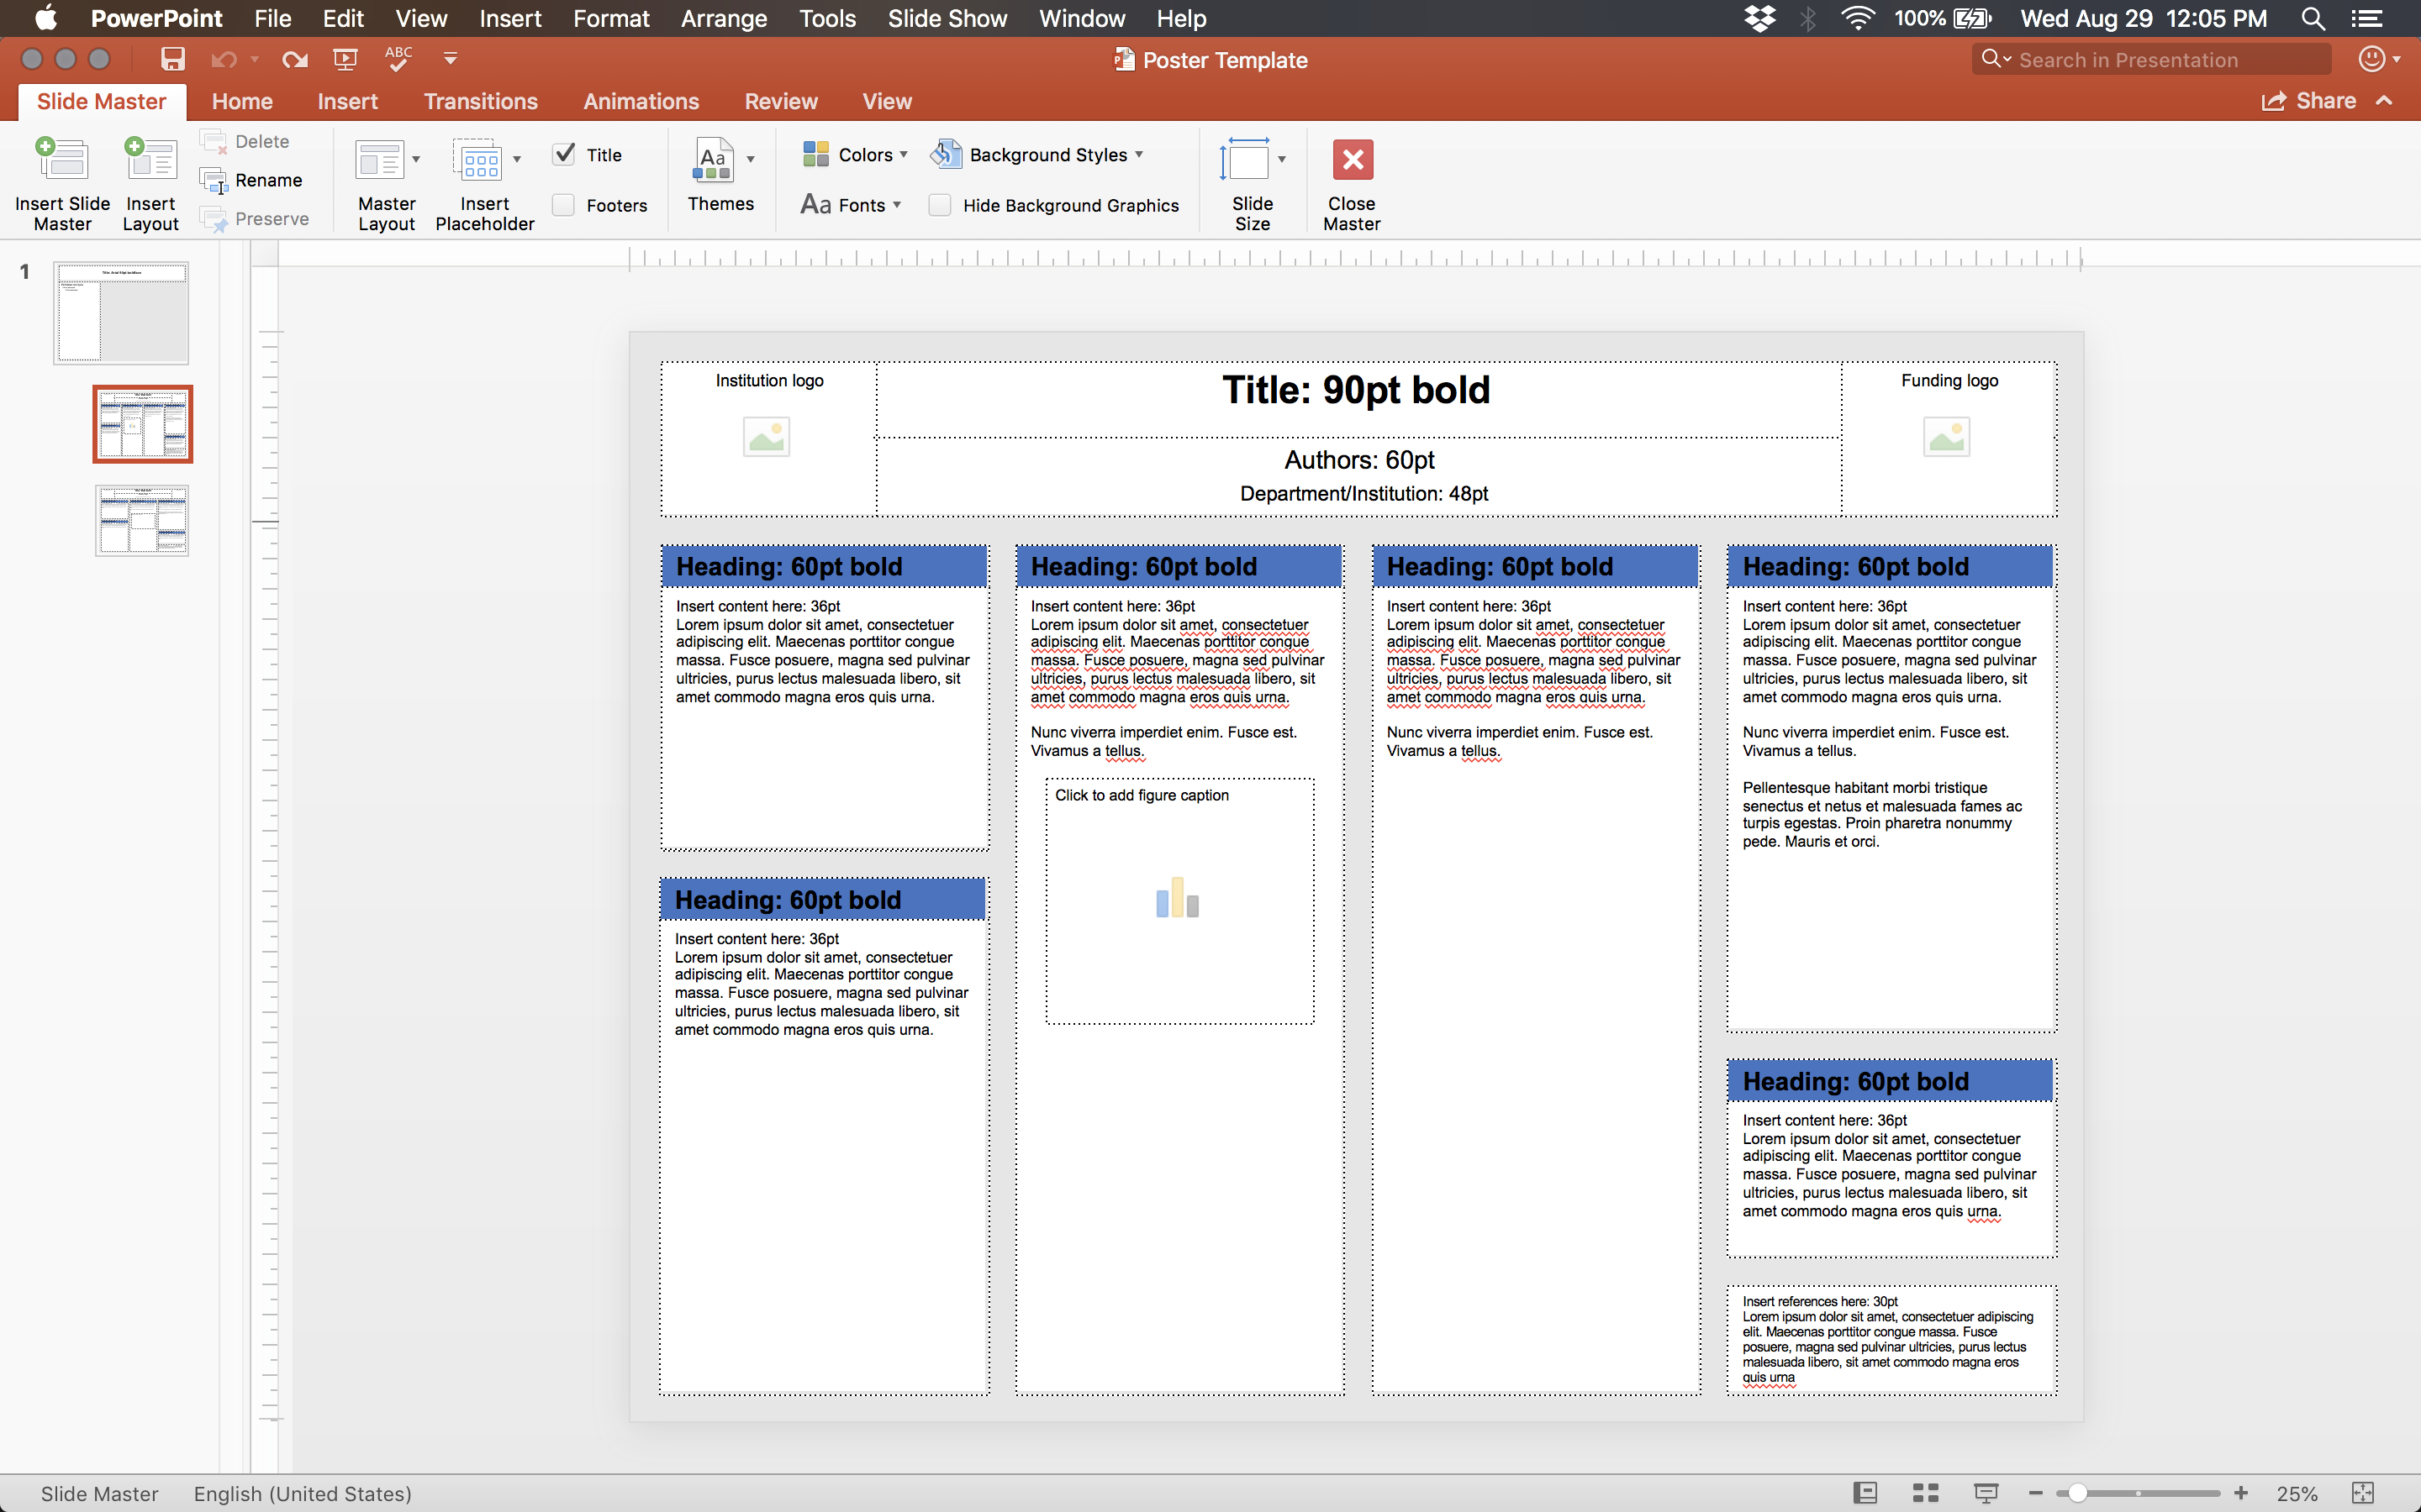

Select which template you would like to edit from the list on the left

Changing the font

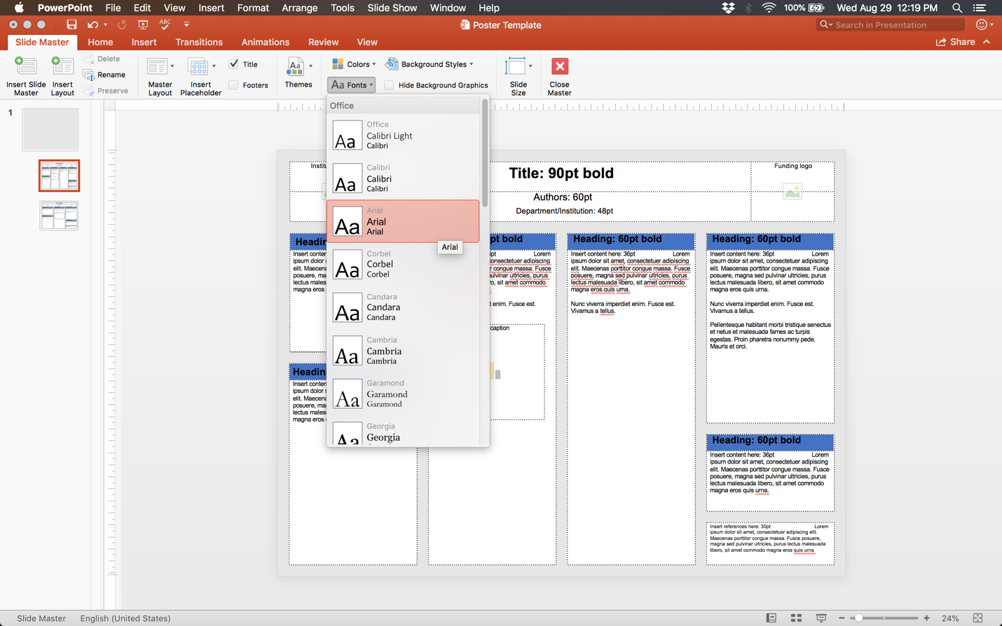

Changing the background color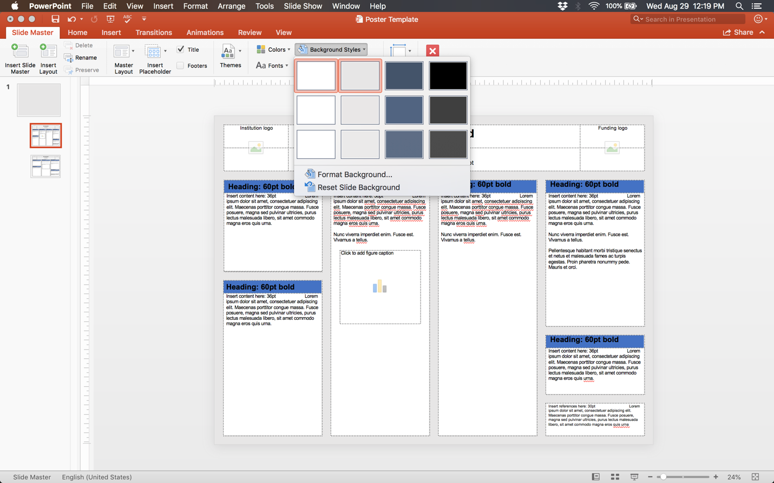

Changing the color scheme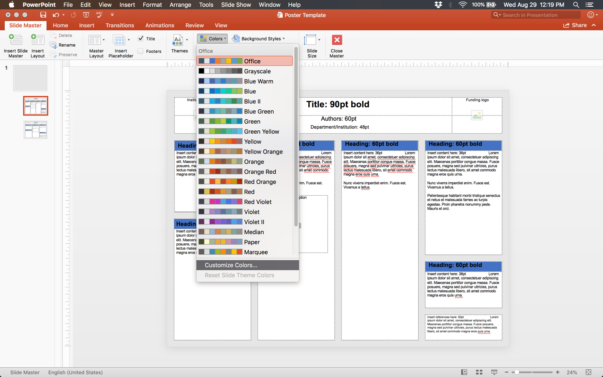

Example of “Yellow Orange” color scheme 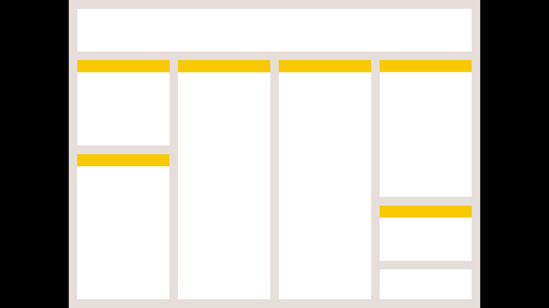

You can further customize the coloring by selecting “Customize Colors”

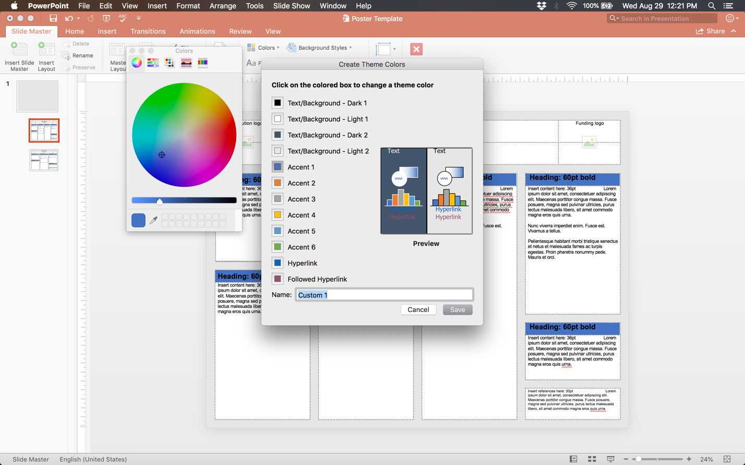

Example of custom color scheme (this color is *not* advised) 

If you need to adjust the boxes, it is best to specify the exact size and location of each box using the “Format Shape” menu

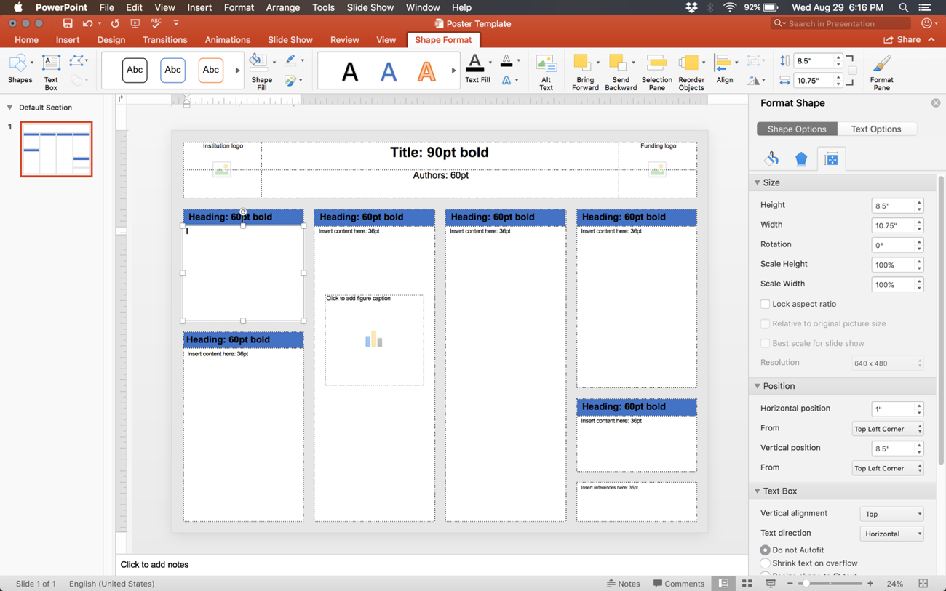

“Guides” are useful in aligning content on your poster and can be created by right clicking around the perimeter of the poster

